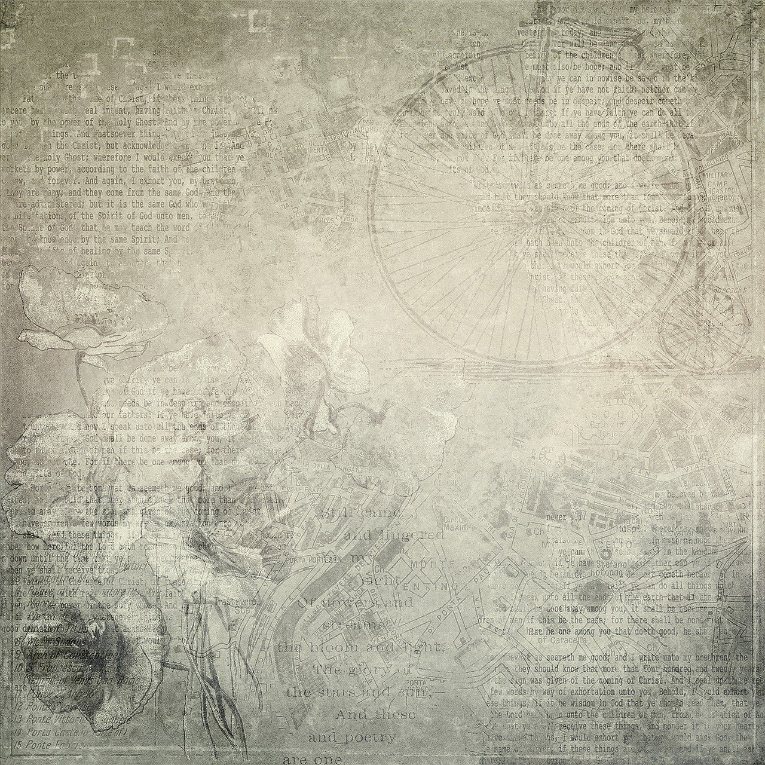
this
is
where
I
note
down
my
ideas

40 page lined/templates journal

This journal is used and filled by: [Name]
[Affiliation]

Brain
Storming

Reflective writing (e.g. write down what comes to mind for 3 minutes non-stop)

Idea sheet #…
name of idea:
description
pros
cons
conclusion
Visual idea sheet #…
name of idea:

What I(‘d) say |  | What others (might) say

Dear future, I am writing to you … | Dear past, thanks …
Draw
Draw

