BOP –
Glove box MBraun Labmaster located in ØU16/Battery Lab
- Glove box responsible: Ville Miikkulainen, office ØU 44, mobile: 45 19 63 23, email: k.v.miikkulainen@smn.uio.no
- Authorization required
________________________________________________________

General things to know before using the glove box
- ØU16 glove box is dedicated to lithium battery assembly
  - Li batteries are sensitive electrochemical systems, contamination should be avoided
  - Do not take new chemicals into the glove box without consulting the responsible person
- Material safety data sheets are available in the folder on the book shelf opposite to the glove box
  - Read relevant documents before working
- Use log book whenever you use the glove box
  - This is important in keeping track on the usage
  - Monitor Ar bottle pressure before using, it should be ???
- Every authorized user has his/her own plastic box inside for samples etc.
  - This way the glove box stays in order
  - More boxes are available when needed
- Report alarm messages to the responsible
  - High level of inertness is crucial in Li battery assembly
- Report shortage in chemicals and consumables to the responsible
  - Refill will be arranged as soon as possible

Using the box
Keep the glove box clean and in order! Put chemicals and equipment back to their place after using them. If you spill something you MUST clean it before leaving the box.
Checklist before operating with the glove box:
- Is the regeneration indicator green?
  - Yes Box is being regenerated and cannot be used until the following day
- Is the big antechamber in use?
  - Yes Come back later
- Is either O₂ or H₂O levels >10ppm?
  - Yes Do not use the box, see log book for latest entries, contact responsible if there is no explanation for elevated levels
If you can answer “No” to all of the questions, the glove box is operational.

Getting material into the glove box
Your material (and/or) its container should handle reduced pressure if you intend to import them into the glove box. The normal setting for antechamber vacuum is ??, but it can be adjusted if necessary. In that case contact responsible person. There are two things that can go wrong when using the antechambers that you need to be aware of.
- Don’t open both inner and outer doors of the antechamber simultaneously!
- Don’t open the inner door if the antechamber is filled with ambient air!

Using the small antechamber
You can import small items through small antechamber. It is faster than the big antechamber. Check that the chamber is under vacuum and that the vacuum/refill valve is closed.
- Refill with argon, using the valve under the chamber.
- Open the outer door and put your things inside. Close the door.
- Pump vacuum and refill with argon 3 times with the valve under the chamber.
- Open the inside door and take your things inside. Close the inner door.
When you are done, pump vacuum into the chamber and leave the valve in “closed” position.

Using the large antechamber
Go to Antechamber-window. Check that there is vacuum in the chamber, there are no evacuation-purge cycling going on, and the antechamber is free to use. Antechamber should be in hand mode.
- Push the “Refill antechamber” button (turns red). When the antechamber is refilled, push the button again to stop the refilling (turns green).
- Open the outer door and put your things on the steel tray.
- Lower the door fully before sealing it. Turn the locking mechanism clockwise until you feel some resistance and then about 60 degrees more. If you close it more than this then the door will start to bend outwards and leak. The door will feel loose when the chamber is under vacuum, but do not tighten the door any more.
- Change to Automatic mode.
- Push the “Evacuate/Start Autom.” button. This pumps vacuum and purges the chamber three times and takes approximately 20-25 minutes with default settings. Turn on the “In Use” tag.
- When the program has finished (“Evacuate/Start Autom.” Button=red), you can open the inner door.
- Gently close the door while you work.
- When you are done using the large antechamber, pump vacuum in the antechamber (in hand mode) and leave it under vacuum. Remember to turn the “In Use” tag back to “Free”!

Using the gloves
When using the gloves, remove all rings, bracelets, watches etc. The gloves are durable, but any sharp edges can easily damage them. Also, you need to wear long sleeves (like a lab coat) and gloves (preferably cotton). You are going to get sweaty while using the box, and so do everybody else, so this is for comfort and hygienic reasons. It should not be any direct contact between your skin and the gloves. To insert your hands into the gloves, follow these instructions (can be a bit complicated otherwise):
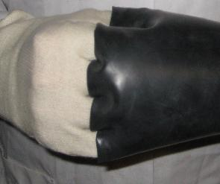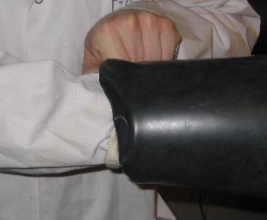
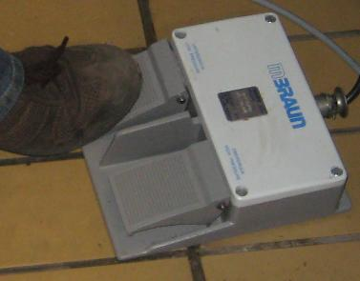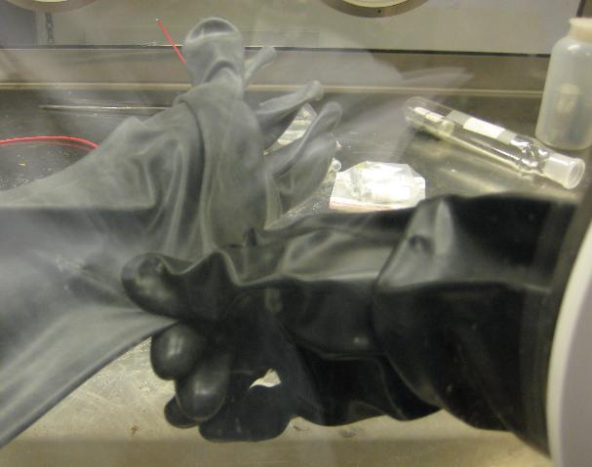
- Insert your fingers into one of the gloves, like shown above. Then use your free hand to help push your hand completely into the glove, as in the second picture.
- Do some finger acrobatics to get your fingers into the second glove, and push your hand into it. This glove will be wrinkly and folded around your hand.
- Step on and hold down the left pedal on the floor. This decreases the pressure in the box. It will stop decreasing the pressure when it reaches a minimum, so just hold it down until you are done.
- Slowly push your arms inside the box while I check the pressure on the display. The pressure must not go higher than 6 mbar. It takes about 5 seconds to do this.
- Use your “good” hand, the hand in point 1, to hold the other glove while you gently stretch out the second arm.
- Now you are done, so you can let go of the pedal on the floor. The right pedal increases the pressure (until a maximum of 6 mbar), so you can adjust the pressure in the box to a comfortable level. It is not possible to damage the box with the pedal, so feel free to modify the pressure at any time with it.
- Put XL protective gloves on the glove box gloves. This helps keeping the gloves in condition for longer time.

Taking something out of the box
- If you are transferring stuff right after you have transferred something in, you can just open the inner door and put your items inside the antechamber. Close the inner door! Then, open the outer door and remove your items. Pump vacuum into the chamber. In case of large chamber, also remember to turn the “In use” sign to “Free”.
- If you don’t know the status of the chamber you are about to use, do evacuate-purge cycling as is done when you import something into the chamber (Chapter 3). Then, follow the guideline of case a.

