SOP for using the oxyhydrogen torch
Before using the torch prospective users must be trained by Chris Thomas (Ø-138) (for NAFUMA personnel) or Anja O. Sjåstad (Ø-130) (for other groups)

- Wear face shield (welding face shield or welding glasses and ordinary face shield)

- Check that fume hood is on

- Check that all valves for both O₂ and H₂ are closed (gas cylinders, regulators and torch).

Open for H₂-gas flow
- Open main valve on H₂-gas cylinder.
- Open slowly 2nd valve on the wall
- Check the pressure of first gauge on the wall (minimum allowed cylinder pressure 30 bar). The second gauge is fixed at 2.5 bar

Ignite flame on torch
- Open the hydrogen valve on the torch, and ignite fire by match or spark lighter.
- Adjust hydrogen flow to obtain an orange flame.

- Open for O₂-gas flow
- Open main valve on O₂-gas cylinder.
- Open slightly the 2nd valve on the wall (counter clockwise), and check the increase in pressure of first and second gauges on the wall regulator. Max operating pressure for second gauge is 2 bar.
- Open carefully the oxygen valve on the torch and adjust flow to blue colour for use.

Adjust flame on torch for a short break (max 5 minutes)
- Close oxygen valve on the torch
- Adjust hydrogen flow on the torch to give an orange flame
- Reset H₂/O₂ flame (after break) by carefully open oxygen valve on the torch and adjust flow to give blue colour.

Close H₂/O₂ gas flow at end of experiment
- Close O₂ tap on torch on – and main valve on H₂-gas cylinder. The remaining gases in the lines will be treated in steps 2-5 below.
- Burn remaining H₂-gas in the line until the pressure of both first and second gauges on the wall decreases to zero. Close H₂ valve on the torch then on the wall.
- Close O₂ cylinder. Release remaining O₂-gas until pressure of both first and second gauges on the O₂ by the cylinder becomes zero.
- Close all valves on both H₂ and O₂ lines and assure both gas cylinders are in closed position. Do not over-tighten needle values.

Remember to tidy workspace after use
Report any problems or concerns to Christopher I. Thomas (Ø-138) or Anja O. Sjåstad (Ø-130)
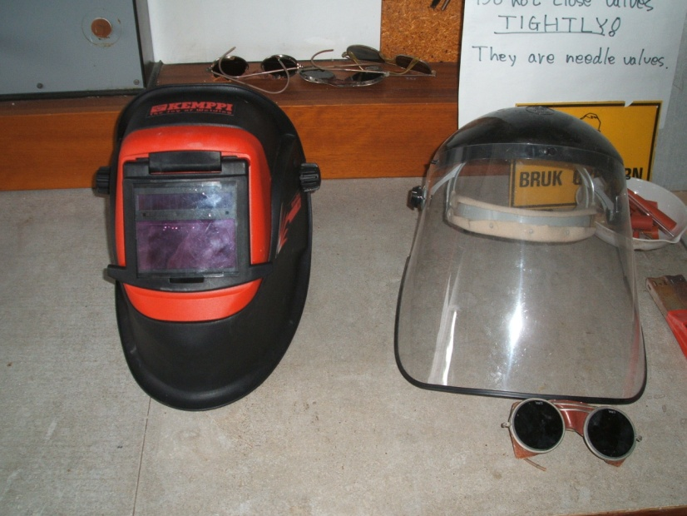
welding glasses and ordinary face shield
Welding face shield

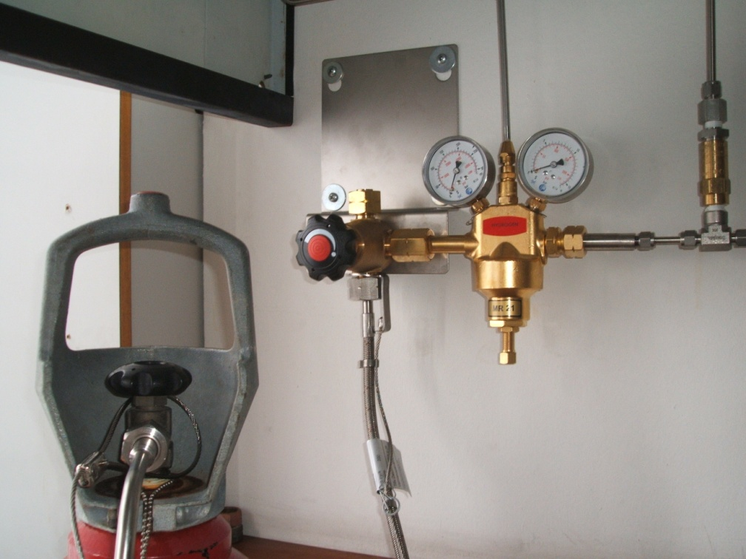
2nd gauge
1st gauge
2nd valve on the wall
Main valve on H₂

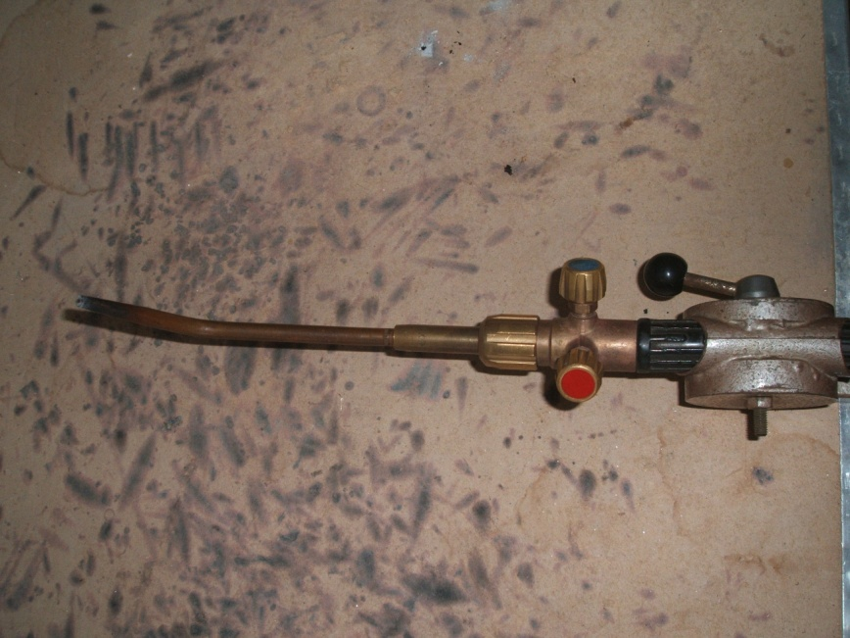
H₂ valve on Torch
O₂ valve on Torch

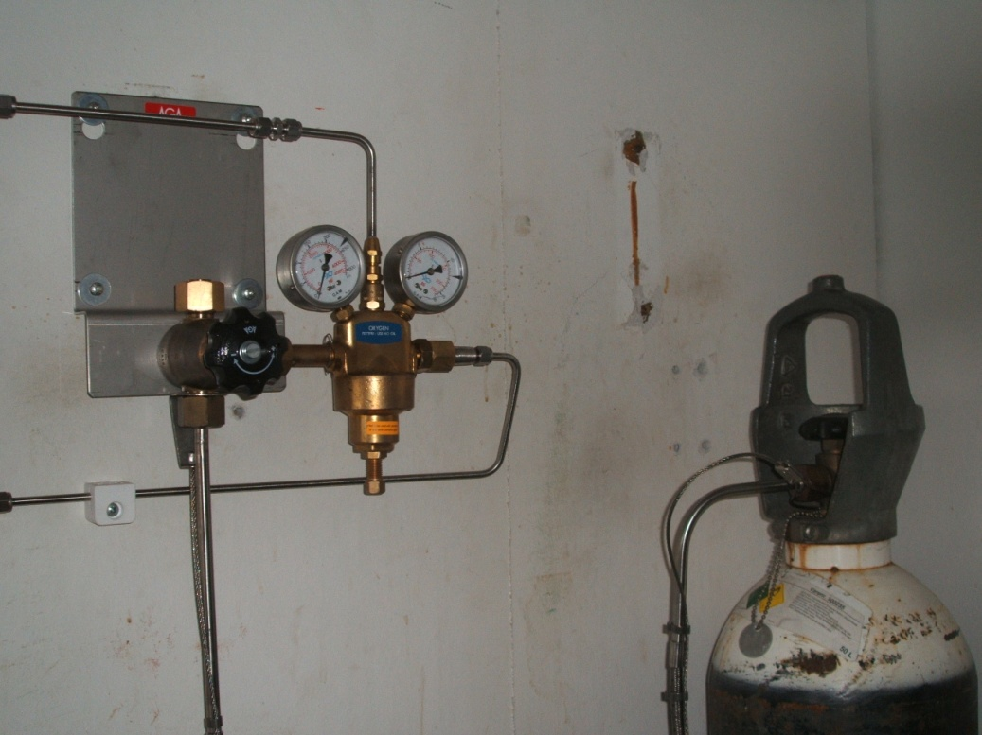
2nd gauge
1st gauge
2nd valve on the wall
Main valve on O₂
SAFE JOB ANALYSIS (SJA)
Name of unit: Department of Chemistry
This SJA concerns: hydrogen torch in room Ø150
Date: 1/11-2010, Agnieszka Gorzkowska-Sobas, Hiroshi Okamoto, Helmer Fjellvåg
Date: 20/3-2012: Christopher Ian Thomas, Anja O. Sjåstad
Date: 22/06/2012: Christopher Ian Thomas, Anja O. Sjåstad

Subtask | Possible cause of undesired event | Precautions to be taken
Hydrogen gas | Flammability/Ignitability | Turn on fume hood
 |  | Hydrogen gas must be always burned out.
Sealing quartz | Damage to the eyes | Do not look at melting part of quartz by naked eye
 | Damage to the face | Use face-shield for protection
 | Skin burns | Keep tidy work place, and maintain good housekeeping
 | Explosion | Think about possible over pressure during sealing treatment  Assure H₂ gas cylinder have at least 30 bar when starting up experiment

