Red text in italics explains how to fill in the risk assessment, and should be removed in the finished document. Red text that is not in italics, should be replaced with information specific for this risk assessment.

PURPOSE/Background
Describe briefly the purpose of the procedure and in which contexts it is used.

responsibilities and SAFETY
The general responsibility for HSE at the Department of Chemistry lies with the Head of the Department. However, the room responsible person must have control and knowledge of all ongoing activities that take place in space, ensure that activities follow established procedures, and provide adequate labelling of laboratory chemicals. For more details on responsibility, see KI’s HSE manual.
See the general UiO procedure Risk management policy in laboratories for an overview of responsibilities at UiO.
General laboratory safety applies. For more information, see KI’s HSE manual.

NECESSARY SAFETY EQUIPMENT
Remove the safety icons that do not apply to this procedure. Glove type may be specified. If othe protective equipment is necessary, change or remove the text under the exclamation mark, or add other icons if appropriate. You may remove the table outline when you are finished.
Safety glasses | Lab coat | Gloves (type) | Fume hood

Chemical and Biological Hazard

4.1 Chemicals
Chemical information | Hazard-(H) and precautionary statements (P)
Chemical name and concentration  Chemical formula  CAS-number  Product numer and link to safety data sheet:  Hazard pictograms:  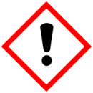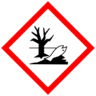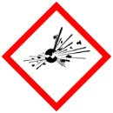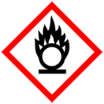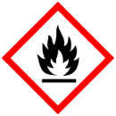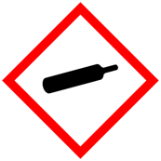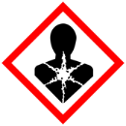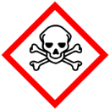 | Write all hazard statements (H-statements) and precautionary statements (P-statements).
Eksempel, hazardous:  Sodium hydroxide 10 M  NaOH  CAS: 1310-73-2  87936 fra VWR  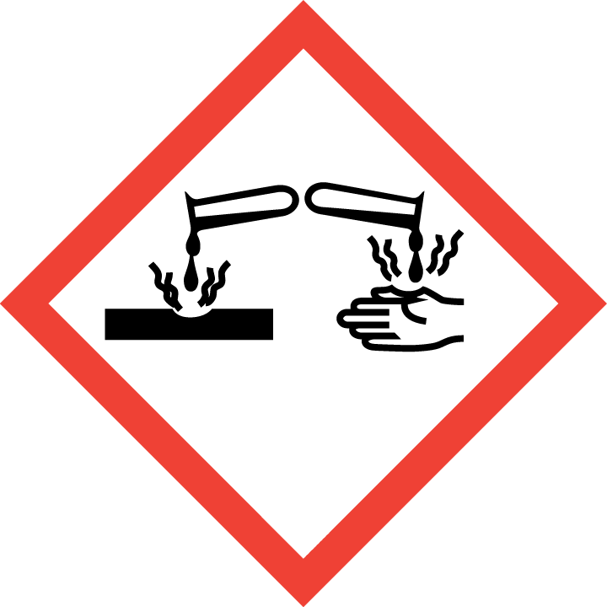 | Hazard statements  - H315: Causes severe skin burns and eye damage.  - H290: May be corrosive to metals.  Relevant precautionary statements  - P280: Wear and eye protection, protective gloves, and protective clothing.  - P301 + P330 + P331: IF SWALLOWED: Rinse mouth. Do NOT induce vomiting.  - P305 + P351 + P338: IF IN EYES: Rinse cautiously with water for several minutes. Remove contact lenses, if present and easy to do. Continue rinsing.  - P315: Get immediate medical attention.  - P303 + P361 + P353: IF ON SKIN (or hair): Take off immediately all contaminated clothing. Rinse skin with water [or shower].  - P363: Wash contaminated clothing before reuse.
Example, non-hazardous:  Glucose  CAS: 50-99-7  G6152 fra Sigma-Aldrich  C₆H₁₂O₆ | Not a hazardous substance or mixture according to regulation (EC) no. 1272/2008.

4.2 Biological Agents

If you are working with pathogen organisms, use a pathogen safety data sheet (PSDS) and fill in the table below. Otherwise, delete this part.

Biological agent | Laboratory hazards, necessary precautions and emergency planning
Neisseria gonorrheae  Risk Group 2  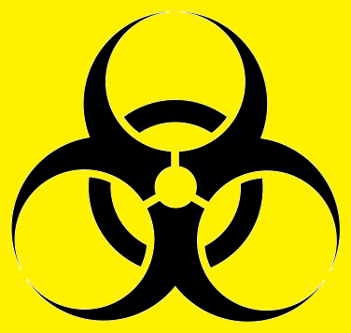 | Containment Level 2 facilities is required  Reported laboratory acquired infections:  - Gonococcal conjunctivitis (eye)  - Cutaneous infections (skin)  The bacteria are mostly known for causing Genital gonorrhoeae.  Wear safety goggles, lab coat and gloves.  Avoid contact with contaminated gloves.  Wash hands after work.  If exposed seek medical assistance.

Special cautions necessary due to reproductive toxicity
Here you describe if the procedure involves chemicals or work that can be harmful to someone who is pregnant or planning for a pregnancy, or are breast-feeding. There are special requirements for working with substances that are classified as carcinogenic, mutagenic or toxic for reproduction class 1A and 1B. If you are working with biological organisms in risk class 2, assess risk by using a pathogen safety data sheet or other relevant documentation.

Exampel 1: This procedure does not involve substances that are classified as carcinogenic, mutagenic or harmful to reproduction (CMR-substances). Therefore, this procedure is considered safe for everyone who plans a pregnancy, is pregnant or breastfeeds.
Exampel 2: Because of …, this procedure is not recommended if you are planning a pregnancy (men and women).
Exampel 3: Because of …, this procedure is not recommended if you are pregnant/breastfeeding.

Equipment and procedure
Here you write equipment list and step-by-step instructions for the procedure.

Necessary equipment:

Procedure:

RISK ASSESSMENT
Assess risk for the different chemicals and work operations in the table under 7.1. The written assessment in the table is the most important, but also use the risk assessment matrix to estimate likelihood and possible consequences (righthand column). When using the matrix, assume that the precautionary measures and emergency measures in the assessment will be followed.
Consider the possibility for substitution of hazardous substances in 7.2. Finally, make a total assessment of the procedure in 7.3.

Risk assessment; step by step
Part of procedure |  | Unwanted scenarios | Precautions | Emergency planning | probability ∙ consequences
 | Describe chemical or work operation with risk | What can go wrong? | What can be done to prevent accidents. | How can damage be minimized/contained in case of an accident | Enter the numbers for probability and consequences. Color the cell according to the risk matrix

Substitution
According to Norwegian law, substitution of hazardous chemicals must be considered. Write your assessment here.
Example: Substitution has been considered, but has not been found suitable for this procedure.

7.3. Overall risk assessment for this SOP
Make an overall risk assessment based on the individual assessments above. The overall assessment should be equal to the highest risk category you have used in the risk assessment matrix.
Risk categories
- Red: P∙C=10-25 the overall risk is an unacceptable risk. New precautions to reduce the risk should be established.
- Yellow: P∙C =4-9 the overall risk is medium. New precautions to reduce the risk should be considered.
- Green: P∙C =1-4 the overall risk is fully acceptable - minimal risk.

WASTE DISPOSAL
Here you write directions for responsible waste disposal. The table below includes many examples. Remove those that are not relevant.
Waste type | Volume/ amount | Disposal method | Warnings
Describe the type of waste. If several types of waste should be disposed of in the same manner, you may write them on the same line |  | Describe how the waste should be disposed of | If there are special considerations that are important to be aware of for this type of waste, write it here.
Used disposable equipment and gloves contaminated with radioactivity | - | Dispose in hazardous waste box for radioactive waste. | Hazardous waste box should be stored behind plexiglass
Contaminated gloves and used disposable equipment | - | Dispose in hazardous waste box.
Hazardous chemical leftovers |  | Collect in suitable containers according to chemical waste guide (specify correct container for waste produced by this procedure) | If incompatible chemicals are disposed of in the same container, this may lead to chemical reactions involving heat- or gas production
Non-hazardous chemical leftovers |  | Collect in suitable container for non-hazardous waste
Genetically modified organisms and microorganisms in rask class 1 and 2 |  | Waste should be autoclaved and then diposed of in containers for biological risk waste.

Declaration of compliance
I will follow the procedure described above and use necessary safety equipment

____________________________
Student

