MASTER PROJECT:
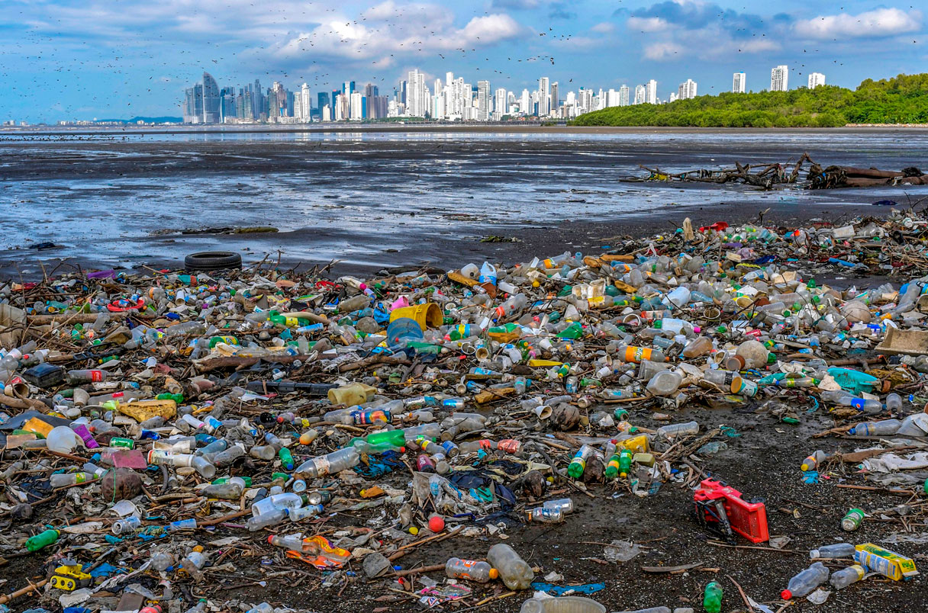
Sustainable plastics: Synthesis of biobased polymers and crosslinkers for the next generation high-performance bioplastics
Figure 1: LUIS ACOSTA/AFP/GETTY IMAGES. Collected from Science.org
Plastics are some of the most abundant materials on earth. They can be designed for almost every application, are cheap to produce and durable and therefore, the demand is high. Annually, the production of plastics is on the million-ton scale (1). However, the durability of these materials comes with a drawback, as often the lifetime of the material is a lot greater than the service life. This in combination with the use of oil-based carbon for production and difficulty of recycling, led to an industry with high carbon footprint and a significant waste problem. The design and development of sustainable polymers, the backbone of plastics, is therefore crucial (2).
Despite industrial production of biobased and biodegradable polymers, there are challenges yet to overcome. Often the synthesis of bio monomers demands elaborate procedures that are difficult to scale up, and the produced materials usually suffer from brittleness and poor thermal properties (3). Therefore, the market share of bioplastics is still low (1).
The scope of the master project, carried out between SINTEF and the Soft Matter group at UiO, will be to design and synthesize biobased polymers and crosslinkers to address the need for sustainable plastic materials of high performance.
If you are interested in master science that encompasses organic synthesis, green chemistry and polymer science, contact Nora Uggerud (SINTEF/UiO) (mail: nora.uggerud@sintef.no) for more information.

References
1. OECD. Global Plastics Outlook: Economic Drivers, Environmental Impacts and Policy Options. Paris : s.n., 2022.
2. Sustainable Polymers Square Table. Pablo, J. de and Hillmyer, M.A. s.l. : Macromolecules, 2021.
3. Avérous, Luc and Pollet, Eric. Biodegradable Polymers. Green Energy and Technology. London : Springer-Verlag, 2012.

