Dette er ment å bli en oversikt over ulike ressurser som PhD kandidater kan trenge gjennom løpet sitt

Resources for PhDs

Contents
Resources for PhDs 1
Personal development 1
MN personal counseling service (ForVei): 2
Occupational Health Service Unit: 2
Verneombud 2
Bedriftshelsetjenesten BHT/ Occupational health services 2
Sports and Physical Health 3
Insurance 3
The Studentskibnaden (SiO) Assosications 3
Professional development 3
Career support for early career researchers: 3
The UiODoc Union 3
International Staff Mobility Office (ISMO) 3
Employee benefits 3
Scientific practice, research integrity and research ethics 4
The Science Ombud at UiO: 4
Ethical guidelines for supervision relationships at UiO: 4
UiO’s Speak up/report: 4
For the supervisors (and interested candidates) 4
PhD supervision modules (soon in english) 4
Information flow 5
PhD and postdoc bulletin: 5
PhD webpages: 5
PhD Facebook group: 5

Personal development

MN personal counseling service (ForVei):
https://www.mn.uio.no/english/studies/forvei/index.html
Do you need someone to talk to? ForVei is a personal counselling program for all students admitted to a study program at the MN Faculty. Our main goal is for you to enjoy being a student at our faculty and to acquire a sense of achievement.

Occupational Health Service Unit:
https://www.uio.no/english/about/organisation/los/ebht/index.html
The Occupational Health Service Unit supports employers, staff, working environment committees, and safety representatives in creating safe and sound working conditions.
The unit comprises specialists in occupational health, the psycho-social and organizational working environment, ergonomics, and occupational hygiene. The Occupational Health Service has a free and independent position at the University of Oslo.

Verneombud
https://www.uio.no/english/for-employees/employment/trade-unions/
For any and all concerns regarding the physical or psychosocial workplace, don't hesitate to contact your local safety deputy or "verneombud", they have coursing for a range of subjects and can help guide you to different resources. Be noted that they have a duty to report certain serious topics to the nearest leader, like bullying or crime. If you are in need for a confidential consultation, see the Occupational health services or "BHT".
Safety representatives shall be engaged in cases of importance for the working environment. Their role is described in the Working Environment Act (arbeidstilsynet.no) . Examples:
Ensure that the safety, health and welfare of all members of staff are properly taken care of; see for example the procedure in cases of harassment
- Ensure that all members of staff receive necessary instruction and training
- Report work accidents
- Be represented in the Central Working Environment Committee (AMU) and the Local Working Environment Committees (LAMU)
To find your local safety deputy at the Chemistry department: https://www.mn.uio.no/kjemi/english/about/hse/Find%20your%20safety%20representative/index.html

Bedriftshelsetjenesten BHT/ Occupational health services
https://www.uio.no/english/for-employees/employment/hse/ohsu/

BHT is an independent organ within UiO with a large range of services; ergonomic help, physical health, occupational vaccines, pregnancy, stress, work-related conflicts, chemical working environment, and more!
A lot of these subjects can you discuss with your supervisor or your safety deputy about, but for BHT is a very good resource for subjects that can be difficult. They have duty of confidentiality, which makes them a good, local resource for counseling.

Sports and Physical Health
https://www.uio.no/english/for-employees/employment/welfare/exercise/
UiO offers a range of different services related to sports and physical health. As an employee, you are entitled to 90 minutes of physical exercise during working hours.
UiOBIL is the workplace sports organization where you can participate in a large selection of sports with fellow UiO colleagues https://foreninger.uio.no/bil/english/.
As an employee at UiO, you can receive a discount on memberships in the SiO Athletica gyms https://www.uio.no/english/for-employees/employment/welfare/exercise/sio.html.

You can also access certain gyms for free in specific timeslots by showing your UiO employee card. Note that Domus Athletica also has a swimming pool, in addition to offer courses and studio gym access like the other gyms https://www.uio.no/english/for-employees/employment/welfare/exercise/access-training-centers.html

Insurance
https://www.uio.no/english/for-employees/employment/insurance/
It's important to be insured at the workplace and when traveling for work, therefore one should make themselves familiar with this page to see what you need to be aware of as an employee at UiO.

The Studentskibnaden (SiO) Assosications
https://www.sio.no/en/associations
Some PhD students might live in the SiO housing when arriving at UiO, but SiO also offer a large range of student associations. As a PhD student, you are an employee and not the target student for these associations, but if you have a hobby or interest feel free to contact those unions regardless. It can be a great way of meeting people and doing activities at the same time!

Professional development

Career support for early career researchers:
https://www.mn.uio.no/english/research/phd/career-support/
As an early career researcher, it is your responsibility to consider and plan your career, and as your institution, we consider it our responsibility to support you in this process.

The UiODoc Union
https://foreninger.uio.no/uiodoc/

They describe themselves as "UiODoc, a group of PhDs and postdocs at the University of Oslo whose mission is to promote the common academic, professional and social interests of all academic staff employed on a temporary basis at UiO… Every PhD, postdoc or other temporary staff at UiO is automatically member of UiODoc and therefore represented by us. "
They have different events that one can look into for a introduction https://foreninger.uio.no/uiodoc/events/.
They also offer help with locating different resources for PhDs https://foreninger.uio.no/uiodoc/resources/

International Staff Mobility Office (ISMO)
https://www.uio.no/english/about/vacancies/ismo/

ISMO supports incoming international staff, PhD candidates, guest researchers and their families with relocation to UiO. They help before, during and after coming to Oslo. They can offer personal guidance and help, but they also offer general courses and events about all kinds of topics.
https://www.uio.no/english/about/vacancies/ismo/courses/
https://www.uio.no/english/about/vacancies/ismo/events/

Employee benefits
https://www.uio.no/english/for-employees/employment/welfare/
UiO has collected a bunch of different employee benefits which is smart to look into!
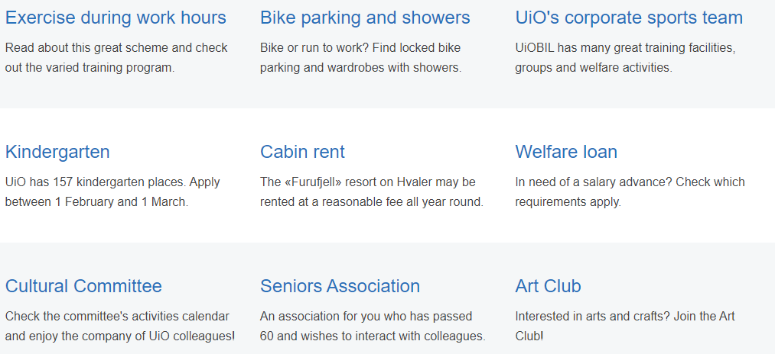

Scientific practice, research integrity and research ethics

The Science Ombud at UiO:
https://www.uio.no/english/about/organisation/science-ombud/
The Science Ombud is an independent and impartial authority for all academic staff at the University of Oslo, for issues and disputes concerning good scientific practice, research integrity and research ethics.

Ethical guidelines for supervision relationships at UiO:
Ethical guidelines for supervision relationships at UiO - University of Oslo
The ethical guidelines adopted by the university board as foundation to provide students and PhD candidates with high-quality guidance.

UiO’s Speak up/report:
https://www.uio.no/english/about/hse/speak-up/index.html
Tell us about your learning environment, both criticism and praise! In particular we ask that you notify severe, censurable conditions. If you discover censurable conditions or behaviour that may be detrimental to UiO or to individual persons at UiO, please tell us.

For the supervisors (and interested candidates)

PhD supervision modules (soon in english)
https://studmed.uio.no/elaring/phd/veiledning.shtml
E-læringsmodul om PhD-veiledning. Et hjelp til veiledere av PhD-kandidater men kan også være være nyttig for PhD-kandidatene selv. Modulen består av kapitler med tekster om veiledning, henvisninger til faglitteratur og kilder (som for eksempel regelverk).

Information flow

PhD and postdoc bulletin:
https://sympa.uio.no/mn.uio.no/subscribe/mn-phd-candidates?previous_action=subscribe
Sympa is the source for mailing lists at UiO. Do search for the lists you want to join and sign up. The link above goes to the PhD and postdoc bulletin.

PhD webpages:
https://www.mn.uio.no/english/research/phd/
This is a great contact point for a lot of resources specifically for PhDs and can give a lot of information about duties and the road ahead.

PhD Facebook group:
https://www.facebook.com/groups/mnphd
If Facebook is your communication platform, then this is the solution.

